Ms. Flaherty’s Classroom News
for the Week of May 1, 2017
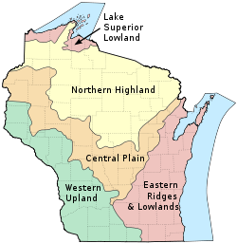 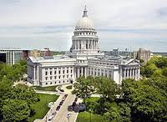 Dear Parents,
My students have begun working on their Wisconsin Project. At this time your child should have completed their cover, title page, five region map, current events, and collage. The flip book should be completed this week. In class, students have begun working on their essay about a famous Wisconsinite. Please ask your child which person they chose for this project. They will also have class time to complete their products map and Wisconsin government assignment this week.
National Screen-Free Week begins Tuesday, May 2nd. Most of my students have decided to participate in this exciting challenge! I have many families that have decided to join them. The purpose of this special week is to take a healthy break from TV/electronics and refocus on activities that are more academically, social, and physically rewarding. Thank you for helping your child survive throughout the week. All fourth grade “Survivors” will be invited to attend a special field trip celebration.
I am proud to say my students were chosen to participate in Jeffery’s latest video, “Hallway Behavior, the Jeffery Way.” This honor was given to us because my class has consistently shown they have excellent hallway behavior. They are good role models for other classes to follow. Our focus in the month of May is to model excellent behavior in the lunchroom.
Sincerely,
Ms. Flaherty

Social Studies: Wisconsin Writing: Informational ELA: Summarizing, Text Evidence, Comprehension Math – Finish Unit 11 “3-D Shapes, Weight, Volume, & Capacity” - - Begin unit 12, “Rates”

Important Dates: Tues.–Mon., May 2nd–May 8th - Screen-Free Week, Help your child meet the challenge! Fri., May 5th - Leadership Dance Tues., May 9^{th -} PTO Meeting 6:00 p.m. in the Library (Elections for Officers) Fri., May 12th – Spirit Day; Popcorn 50 cents per bag (limit two bags) Fri., May 26th – Half Day for Students and Staff Mon., May 29th – No School, Memorial Day Tues., May 30th – 4th Grade Madison Field Trip! Fri., June 2nd – Track & Field Day; Ice Cream Social 5:00-8:00

