Ms. Flaherty’s Classroom News
for the Week of February 20, 2017
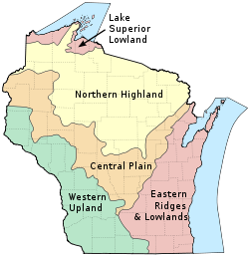
Dear Parents,
Students enjoyed Jeffery’s “Time with a Teacher” assembly on Monday, and they’re eager to participate. Information on this exciting fundraiser is found on Jeffery’s website: http://jeffery.kusd.edu/
I look forward to meeting with each of you this week at your scheduled conference time. Students are encouraged to come and participate in our conference. Information regarding our Madison field trip will be given out at this time!
Sincerely,
Ms. Flaherty

Writing: Continue “How To” essay
ELA: Punctuation, Figures of Speech, Begin New Chapter Book
Math – Unit 8 “Area and Perimeter”

Important Dates:
Mon., Feb. 20th – Six Flags Reading Log Due Tues., Feb. 21st-Monday (morning) March 6th – “Time with a Teacher” Raffle Tickets Due Wed., Feb. 22nd – Parent Teacher Conferences (3:10 – 6:10) Thurs., Feb. 23rd – Half Day for Students, dismissal at 11:15 - - Parent Teacher Conferences (12:00-3:10 & 5:00-7:00) Fri., Feb. 24th – No School for Students - - Parent Teacher Conferences (7:10-9:10 AM) Mon., March 6th, 8:45 AM– Time with a Teacher Raffle Drawing

