Ms. Flaherty’s Classroom News for the Week of December 12, 2016
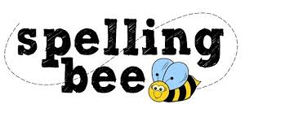
Dear Parents,
We had an exciting classroom spelling bee! I’m proud of all my students. The following top five students are in the grade level finals: Sarah, Isabella, Chase, Zach, and Jayme. Congratulations to all of them! I know they will study hard this weekend. The grade level spelling bee will be on Monday.
Students will take their second MAP test on Wednesday, Dec. 14th. This test will focus on reading skills.
Several students have already completed and turned in their “Secret Angel” cards! They are due on or before Monday, December 19th.
Sincerely,
Ms. Flaherty

Reading Skills – Character Traits & Analysis continued
Math – Begin Unit 5: “Big Numbers, Estimation, & Computation” - Rounding, Multiplying Two Digit by Two Digit Numbers, Estimating Products, Estimating Sums

Important Dates: Culver’s Calendars for Sale! – $5 each; Supply is very limited! Mon., Dec. 12th – Grade 4 Spelling Bee Wed., Dec. 14th –MAP Reading Test Mon., Dec. 19th – School Spelling Bee (top three from each grade level) Fri., Dec. 16th – Spirit Day, Wear school colors & purchase popcorn 50 cents per bag (limit two bags School Wed., Dec. 21st – MAP Math Test Thurs., Dec. 22nd – No School, Christmas Vacation Begins Tues., Jan. 3rd – Students Return

